Plugging in your Cisco VoIP set.
We find that if the set has been idle for a while, it may need re-booting.

- The Ethernet cord should be plugged into the Network port on the back of the set on one end, and into the data jack in the wall on the other end. NOTE: The wall jack is usually a 4-digit number, and the data port is marked with a D, D-1, or D-2. Phone will not work in a port labeled with a V.
- Try unplugging the set and plugging it back in, giving it a couple minutes to re-boot in between tries. May try twice.
- If the set has power, try a Device Reset*** from the Settings button (looks like a gear/cog).
- If the 1st two steps don't work, try plugging the set into a jack that you know is working on the VoIP network (by temporarily removing the set that's there). If the set comes up (then we know it's not the set itself), plug it back into its original location. If it comes up, great, if not, I'll need to notify Network Services. Network Services requires that the set be plugged into the ‘bad’ jack, and I need to provide the Mac address which can be found on the small label on the underside of the set. (a combination of 12 digits and letters beginning with MAC:)
- If all attempts fail, the set may need to be replaced.

Network port:
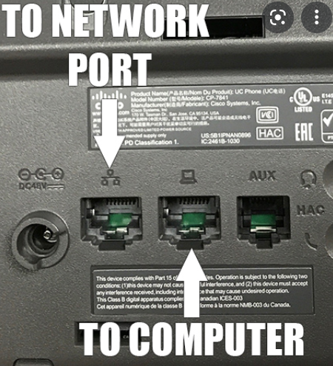
Computer port: If your VoIP set and computer need to share the same Ethernet connection, then there will be another cord plugged into the computer port on the back of the phone to your computer or docking station.

***How to Reset a 7841 VoIP device:
- Press the Settings button (Gear icon)
- Scroll down to application '5 Admin Settings' and press Enter
- Scroll down to application '4 Reset Settings' and press Enter
- '1 All' will be highlighted, press Enter
- At "Are you sure?" press the softkey under 'Reset'
- It will take a couple of minutes for the phone to reset
(To Scroll, use the black ring around the nickel-sized silver button under your display.)
(To Enter, press the silver button.)

How to plug in your VoIP Cisco set
https://www.youtube.com/watch?v=ltJklHwM5eE
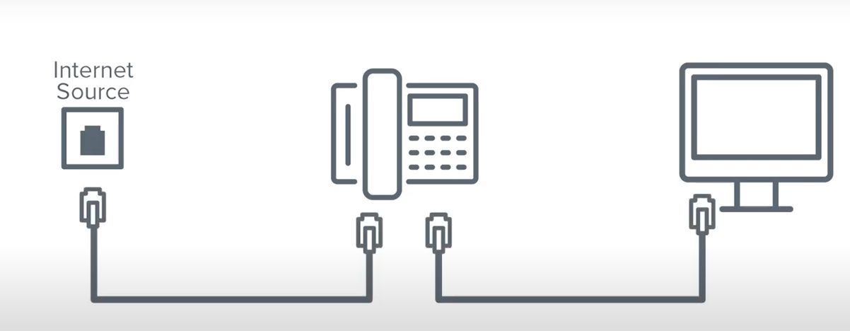

Power Source:
Most sets use POE (power over ethernet). If you’re internet source is too far away from the server and can’t access power this, you may need a power adapter. Once determined, you can request a ‘power brick’ or ‘power cube’ by submitting a ticket.
